**General Description**

The TVA Radial Arm Board is designed to assist in the support and or positioning of a patient’s arm during an OR procedure by sliding under the table pad and allowing extra space for the arm to be placed for maximum clinical benefit and patients comfort. The Radial Arm Board can also be used when additional workspace is needed for health care professionals, or when fluoroscopy is needed.

**Arm Board Instruction for Use**

1. The CZ-400-TVA Arm Board is designed is used to secure and orientate the patients Right or Left arm during vascular procedures
2. Place board on patient table with oval section extending toward the feet and between table hard surface and patient support cushion

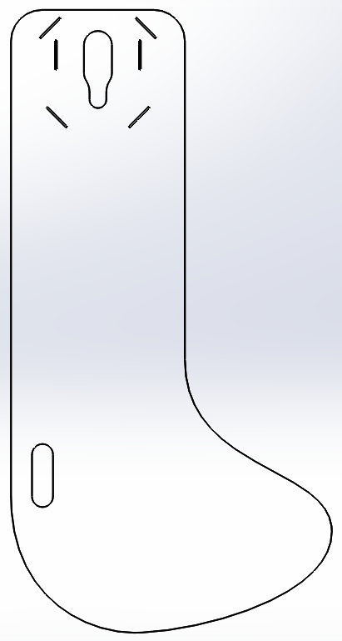

Diagonal Slot (4X)

Horizontal Slot (2X)

IV Slot

1. Arm Board should extend out from the patient bed at approximately 90 degrees (pic)

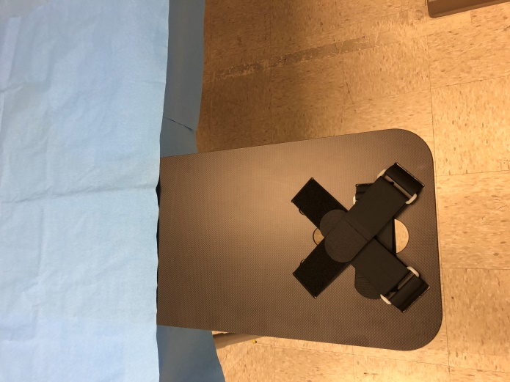

1. 18” strap should be inserted through the horizontal slot in the board, loop side down toward the board, down across the IV recess and back up through the opposite slot. (Pic)

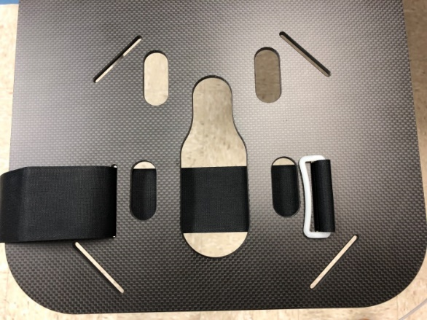

1. 2, 24” straps should be inserted into their diagonal slots loop side down toward the board, down across the IV recess and back up through the opposite slot. (Pic)

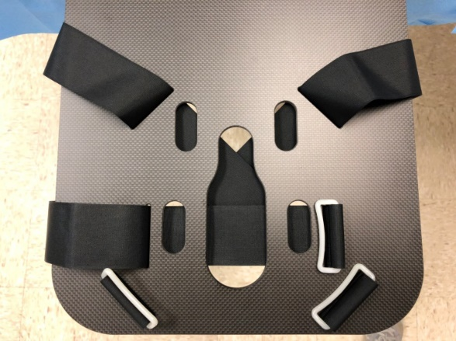

1. Use standard hospital practices draping the arm board
2. The patient may need to reposition to ensure proper arm board placement. Assistance may be required to help the patient position properly relative to the board and table edge.
3. Consider hyperextending the upper arm to limit patient motion throughout procedure

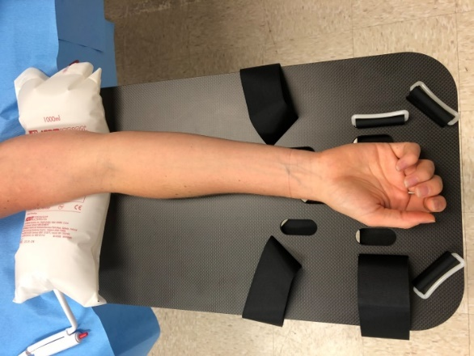

1. Consider hyperextension at the wrist to help with vascular access at the wrist

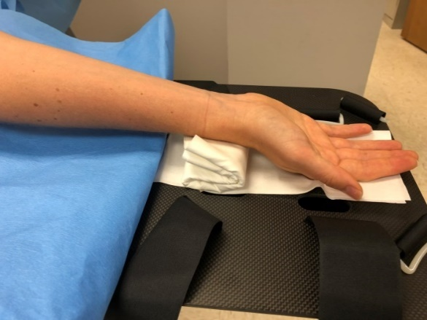

1. Arm Board should be positioned so the horizontal strap is just distal of the thumb across the palm. NOTE: Considering placing 4”/4” gauze or surgical drape around hand to limit wrist strap abrasion.

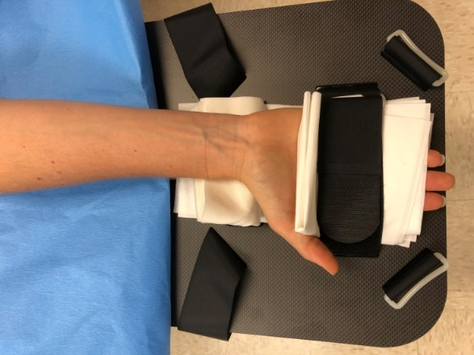

1. Tighten the horizontal strap securely which positions the back of the hand parallel to the Arm Board surface.

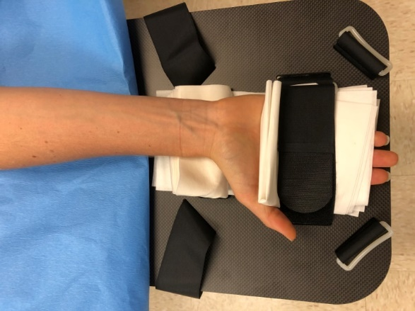

1. Utilize the diagonal straps to finish securing the patients hand. Ensure the thumb protrudes between the horizontal and diagonal strap.

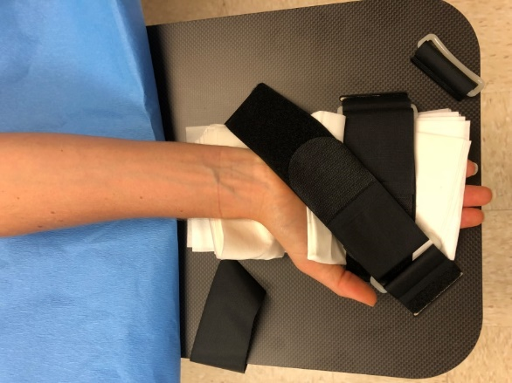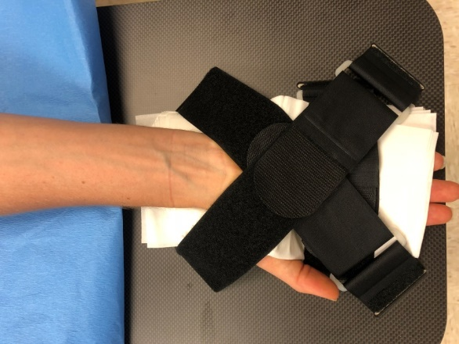

1. Finish draping the arm per hospital standards.

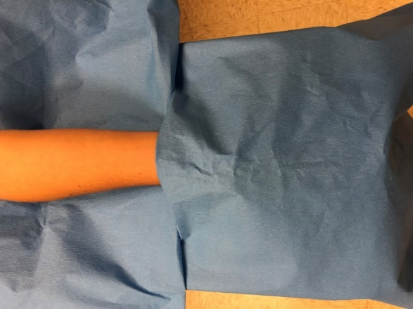



EU Authorized Representative:

CEPartner4U

Esdoornlaan 13

3951 DB Maarn

The Netherlands

www.cepartner4u.eu

TZ Medical, Inc.

17750 SW Upper Boones Ferry Rd.

Suite #150

Portland, OR 97224

Office: 800.944.0187 Fax: 503.639.0239

www.tzmedical.com